**Smart Plant Monitoring System**

Ashish Kumar (2019UCO1518) a,*, Sandeep Jain (2019UCO1522) a, Nishant Goel (2019UCO1529) a

a Netaji Subhas University of Technology, COE Section -1, Dwarka Sector 3, New Delhi, India, 110078

Abstract

Internet of Things is being used in almost all domains around us. Internet has become a basic necessity of people in today's world. IoT is a field of technology which comprises of five components that are sensors, actuators, connectors, network and databases. It is combination of interconnected network comprising embedded sensors and software. An efficient plant monitoring system is still a challenge in various sectors. This project revolves around the idea of building a smart plant monitoring system. The proposed model is integrated with a cloud server and a web application which help the client to control and monitor the status of plants. In this project we have used NodeMCU as the controller, few sensors like Temperature sensor, Moisture sensor, Humidity for collecting data and applied a machine-based curation to regularly check the status of plants health. The primary goal of our project is to reduce interaction of humans and wastage of water by providing the water as per use.

Keywords — IOT, Monitoring, Temperature, Humidity, Moisture

1. INTRODUCTION

1.1 PROBLEM

The world that we live is totally controlled and operated automatically. Automation has taken control of everything, but there are still some important sections in our country that are deprived of this feature. One of those sections is our country’s most primary section, which is agriculture. Technology has no doubt boomed the agriculture and other sections like horticulture in India but it still lacks automation. 61.5% of total population of our country depends upon agriculture sector for their living as per Agricultural Census of India in 2011. Organizations and even households where people care to grow plants do not have the automation. Plant growth can be governed by controlling the parameter of climate and by also introducing automation in plant monitoring. Also, due to traditional methods of irrigation plants used to get over irrigated many times which also damages their health. A monitored irrigation system is needed to tell us the amount of water to be provided to plants. So, there is a potential of automation in this primary section of our country.

* 1. SOLUTION

Our plant monitoring system examines the environment conditions of plant and provides the feedback to the user through any means of network driven device like smartphone, computers, tablets etc. As our daily live is becoming more hectic, most of us are unable to monitor the health of the plant and to ensure that they are getting enough sunlight and water and required ingredients, we introduced this project comprising of various sensors such as humidity sensor, temperature sensor and soil moisture sensor. We designed a system which is triggered whenever the moisture value is above the threshold value (which is governed by the temperature and humidity values) water valve of the system is turned on automatically and appropriate amount of water is provided to the plant. Also, statistical values are shown on an IP address already known to user. Monitoring system has to be connected to the same network over which end user device is connected. So, this solution can be efficiently implemented in the offices, organizations, educational campuses and household which are end users, as long as they are connected to their network, they can monitor the plant health.

* 1. WHERE IS IoT?
* Sensing:

Various sensors such as soil moisture sensor, DHT22 are used in the project to take input to the IOT system.

* Actuators:

Water valve solenoid is used as an actuator in our project. Whenever decision is made by the NodeMCU, relay module is activated which transfer the flow of electrical signals to the water valve solenoid.

* Controller:

NodeMCU (ESP8266) is used as the Wi-Fi module in our project and acts like the controlled of the IOT system.

* Network:

Connection with the end user is built up by the NodeMCU using the network medium provided by the user end.

* 1. VISION AND CONTRIBUTION

Main aim of our project is to provide automation in monitoring of plants and at the same time conserve water as much as possible. Many plants die due to improper monitoring and litres of water is wasted during watering, so our project can save the plant health and also conserve water as there is only controlled watering of plants.

These are the benefits that we have contributed to this section:

• Automated Plant Monitoring

• Data Collection

• Plant health life cycle

• Water Conservation

* 1. PAPER ORGANISATION:

This paper consists of 11 sections that are introduction, literature work, proposed system, hardware description, approach(methodology), algorithm, flowchart, performance evaluation, results, scope of improvement, conclusion, acknowledgment, references.

1. LITERATURE SURVEY

We have gone through various research papers about the works done in this field.

[1] Around 35% of the earthly geographic region was under water. Furthermore, 66% of the piece of land is relying upon rain for the water. Water systems diminishes dependency on monsoons, makes food security better and improves efficiency. There have been numerous hardships in assessing how much water to be given and at what time, since India has wide range of seasons. Under watering and over watering have harmed the plants and degraded soil quality and leading to wastage of water. Subsequently for keep away from such harm we want to keep up with approximate water level in soil as per IOT based plant monitoring system.

[2] One of the research projects conducted by Teemu Ahonen et al at Martens Greenhouse Research Center's nursery, Narpio town tried to analysis four factors that control nursery. For these three business sensors were used alongside with Sensinode sensor. The three sensors were TSL262R light irradiance sensor, SHT75 humidity/temperature sensor and Figaro's TGS4161 CO2 sensor. Several factors were directly connected to the gateway node which estimated environment factors of the nursery such as radiance, temperature and humidity estimated environment factors. There was a broker in the middle though which the gateway hub went about and gets the required information from the sensor hubs. It was found from the experiments that the suitable range for the standalone test was 15 meters.

[3] Nivesh Patil, Shubham Patil, Animesh Uttekar, have explained about PCs or versatile application for control the framework. In their system, we found that all the sensors were connected to on central server. The communication was established by remote modules. Each of the hub performs operation co-ordinately with the components of this network.

The server which acts as a middleware sends the data from the client and the gets the data for the site that is hosted as the web. This framework utilises two modes. Manual mode and auto mode. In auto mode framework the actuator working is decided by the working code itself based on the threshold values and changing parameters, in case of manual mode the user can fully control the system and its working. Further analysing the knowledge discovered and proposing right steps of conformation by establishing correct prototypes of model solution for hardware and software of IOT.

[4] According to Internet of Things and Node MCU, it says that the proposed model the building block step of Internet of Things (IoT). An IoT model various components like physical components like actuators, sensors, microcontroller i.e., central hub, some programming including backend, development of some webpage or an interface compatible with various platforms network. For prototyping purpose, we would be using IoT microcontroller unit (MCU). The MCU board contains low-power processors. These processors support different programming conditions like C, C++, Arduino and are capable to extracting information from the sensor by utilizing the firmware and then upload the data to cloud and can be stored in various databases. One such example is NodeMCU which is an open source. It is based on LUA programming language-based firmware created for ESP8266 Wi-Fi chip.

[5] Divya D, Harsha Mohan Hiremath, Jyothi T U, B S Shubhashree have planned a framework. The framework measured many factors including stream rate and the quality of air. With the quality of air, we can determine the pH. Flow rate sensor is utilized to gauge the aggregate sum of water and supplement arrangement. With the help of the agg. Sum we can set the value of the pH of the soil which is estimated by the pH sensor, the framework chiefly centres around naturally keeping up with the pH worth of the arrangement in repository by contrasting the detected worth and the value extracted from an application. The air quality in which the system is installed wherein the framework is introduced is consistently observed by the air quality sensor

1. **PROPOSED SYSTEM**

The proposed framework comprises of 2 curation frameworks. These two frameworks are based on machine model and user-based model. These curative frameworks are set up to give a brilliant and compulsory criticism to the given climate. The previous is a greater amount of prescient framework contrived on an equipment while, in the user-based model, user has full control of the system. However, this mode of automation and user based depends upon the data gathered from the endpoints. On top of all, the proposed framework configuration is a pub sub framework. The Monitoring equipment is the distributer and the web application are the endorsers and the cloud go about as brokers.

Our proposed model consists of both hardware and the software.

1. Hardware components:
   1. Soil Moisture sensor
   2. DHT22
   3. NodeMCU
   4. Relay Module
   5. Motor
2. Language Used:
   1. Asynchronous JS
   2. C++
   3. JAVA
3. Software Components:
   1. A web-based application

3.1 WORKING METHODOLOGY

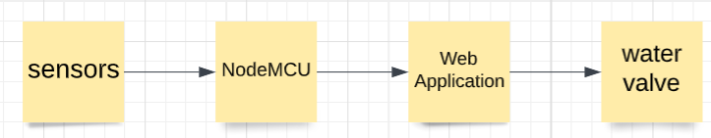

Fig 1. Block Diagram of the System

In the block diagram above, we can see that two sensors are utilized in particular DHT 22 for temperature and humidity, Soil Moisture sensor, a relay module to control the water flow. Single bus information design is utilized for synchronization among DHT22 and MCU sensor. One correspondence process is takes around 4ms. Information comprises of fundamental and decimal parts. A total information transmission is of 32bit, and the sensor sends higher information bits first. Data format: 8bit basic humidity information + 8bit decimal humidity information + 8bit decimal temperature information + 8bit checksum (Error bits). Assuming the information transmission is correct, the check-aggregate ought to be the last 8bit of "bit basic humidity information + 8bit decimal humidity information + 8bit decimal temperature information + 8bit checksum". This large number of sensors are interacted to an open-source Node-MCU (ESP8266) which will go about as a microcontroller. This microcontroller is additionally communicated with 5V power supply. Valves and solenoid Pumps are being constrained by the Node-MCU for effective working of framework. This data is being send to a web application. The controlling of entire framework is automated utilizing NodeMCU and IoT framework.

* 1. CIRCUIT DIAGRAM

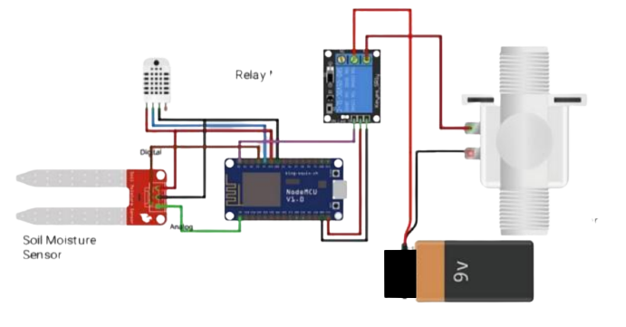

Fig 2. Circuit diagram of the System

1. HARDWARE DESCRIPTION

4.1 Node-MCU ESP8266

Node MCU is an open source IOT platform. While composing GPIO code on NodeMCU, you can't address them with real GPIO Pin Numbers.ESP8266EX offers a total and independent WIFI organizing arrangement; it very well may be utilized to have the application or float WIFI organizing capacities from another application processor. Whenever ESP8266EX has the application, it boots up directly from an outside streak. It contains integrated cache which helps to improve the performance of the system.

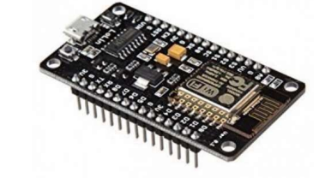

Fig 3. Node MCU

* 1. Soil Moisture Sensor

Soil moisture sensors measure the volumetric water content in soil. Since the immediate gravimeter estimation of free-soil moisture requires eliminating, drying, and gauging of a sample, soil moisture sensors measure the volumetric water content in a roundabout way by utilizing another property of the soil, like dielectric constant, electrical resistance or association with neutrons, as an intermediary for the moisture content.

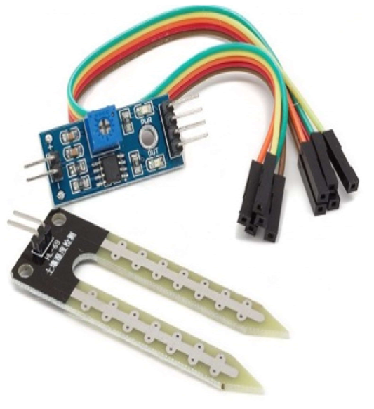

Fig 4. Soil Moisture Sensor

* 1. DHT 22 Temperature Sensor

DHT22 comprise of both moisture and temperature sensor. For estimating moisture there are two anodes with moisture holding substrate between them. Thus, when the moisture changes, the resistance between these anodes' progressions and conductivity of the substrate changes. This adjustment of resistance is estimated and handled by the IC which prepares it to be perused by a microcontroller.

On the opposite side for estimating temperature DHT22 sensor utilize a NTC temperature sensor or a thermistor. A thermistor changes its resistance with change of the temperature since it is variable resistor. These sensors are made by sintering of semi-conductive materials (clay and polymers), which furnish huge changes in the opposition with simply little changes in temperature. The term NTC implies Negative Temperature Coefficient, and that implies that the opposition diminishes with increment of the temperature.

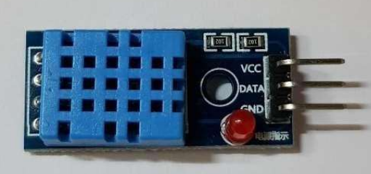

Fig 5. DHT22 sensor

* 1. Relay Module

The relay is utilized to turn ON/OFF the water pump. It’s one end is connected to the "NO" (normally open) and the other terminal is connected to the circuit ground. The single-channel transfer module is significantly more than simply a plain relay, it includes parts that make exchanging and association simpler and go about as indicators to show assuming the module is working and on the off chance that the relay is dynamic or not.

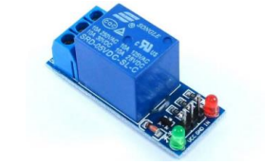

Fig 6. Relay Module

1. ALGORITHM

Algorithm 1 Working

start

*initialize all the sensors*

*collect the sensors output*

*display the value on the web application*

*check the value of soil moisture*

if *value > threshold* then

*Turn on water pump*

else

*goto step 4*

endif

*check the value of DHT22*

*goto step 3*

end

**Algorithm 2** Sending Data

*timedif ← clockTime – previousReadingTime*

*interval = 5secs*

**if** *timedif ≥ interval* **then**

*previousReadingTime ← clockTime*

*Read the sensor input and make XMLHttpRequest*

**If** *status == 400* **then**

*For each parameter in parameters*

*Display parameter. reading*

**If** *pointCollection[parameter].size < 40* **then**

*pointCollection←add[parameter]*

*plot the Chart*

**endif**

**else** *throw error and try re-request*

**endif**

**return**

1. **FLOWCHART**

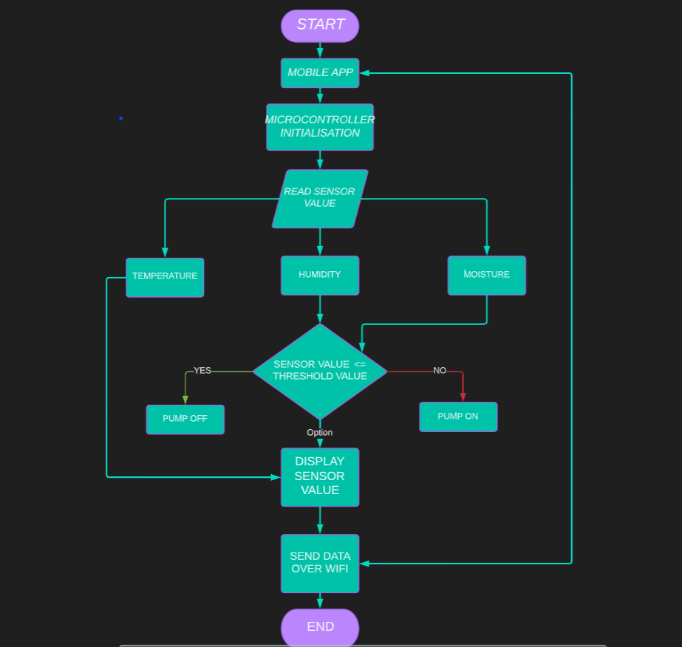

Fig 7. Flowchart of the System

The above flowcharts describe the various stages used in analysing and collecting the data.

* At the point when the power supply is ON, the information module of three sensors (DHT22, moisture) begin to actuate.
* At the point when sensors get ON it will peruse the information from soil and from environmental factors.
* As per the qualities that are distinguished by sensors motor will turn ON/OFF.
* On the off chance that moisture level is high, it will stop the motor and water supply will likewise stop.
* All the extracted values received from the sensor are send to our web application via ESP8266 and is stored in online database (firebase).
* High Charts will create the graph for the data received by Wi-Fi Module.

1. **RESULTS**

The Output of the proposed system is fast, accurate and secure. Hence, the experimental results show that the proposed system is easy to access and monitor the plants under various different conditions.

7.1 EVALUATION

* By comparing with the actual readings and the automated readings that we obtained.
* By comparing with the outcomes of the other similar research done.

7.2 HARDWARE OUTPUT

The hardware setup of the system includes NodeMCU as the central node which is powered by 9V battery source. The sensors including the temperature sensor and the soil moisture sensor are connected to NodeMCU. The relay module act as a switch to turn on and off the solenoid valve. Once the setup is completed, the Arduino code is linked with the IoT application that is designed using AJAX. The application sends the HTTPXMLResponse when it is connected alongside the IP address of the hosted server. Once the reading exceeds the threshold the valve is automatically turned on, allowing the water to flow to the soil. As the threshold is detected again, the valve turns off.

It can be seen that the entire setup is simple, compact and very user friendly

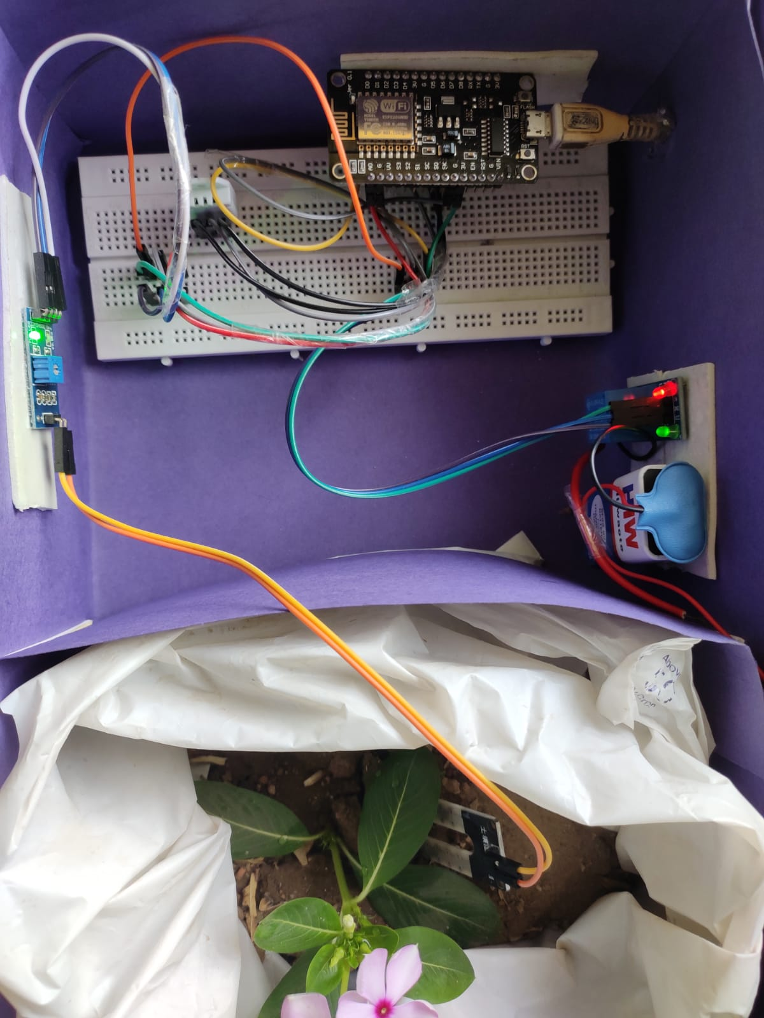

Fig 8. Hardware components of the System

* 1. SOFTWARE OUTPUT

The web application displays the parameters like soil moisture, temperature and humidity. This helps in monitoring the current condition of the plant. When the moisture level falls below 600 or 40% or when the temperature rises beyond normal room temperature, say 30 degrees the water valve is turned on automatically. Once the levels are back to normal the water value automatically turns off cutting the supply of water from the source. The web application collect the last 40 data points and store them on the cloud , these points are then displayed in form of chart so that they can easily be analysed and this time series data can be easily manipulated and studied. Each point as a time stamp associated with it. This can be seen in ESP Visualisation Station. the Application is developed on AJAX which has advantage that its asynchronous, hence the user doesn’t have to refresh the application to monitor real time values which makes our webpage more user friendly and easy to use.

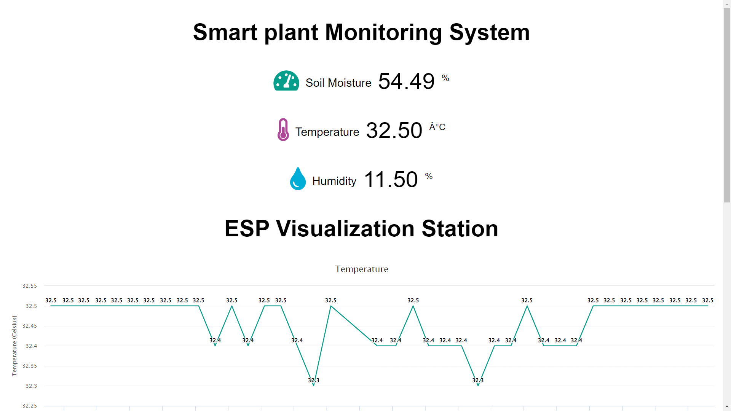 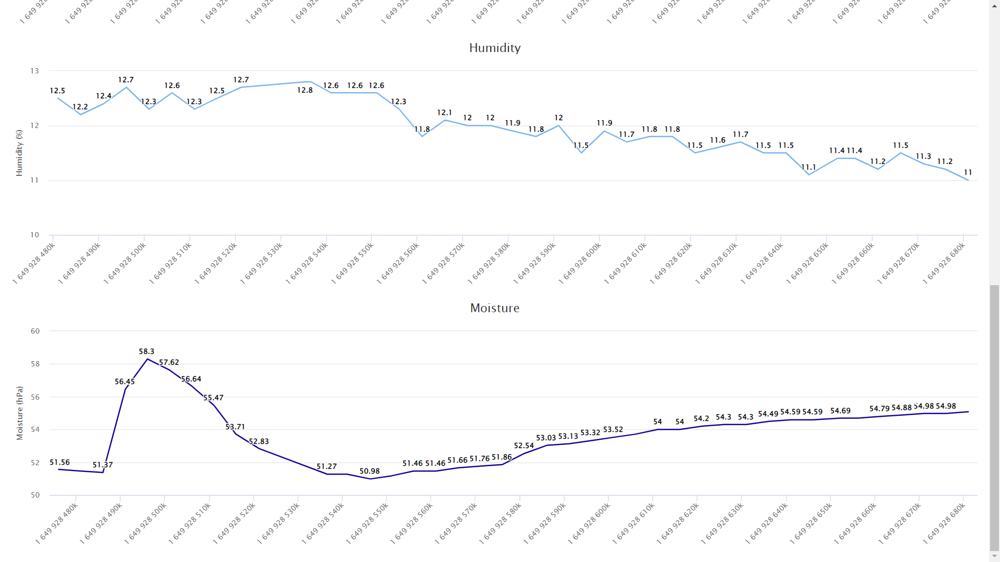

Fig 9.Software components of the System

1. **SCOPE OF IMPROVEMENTS**

The project is very reliable in the limited scale yet will require some improvement for the huge scope level. For future outlook, we could add specific functionality for making the framework more intelligent.

* The performance of the system can be further improved in terms of the operating speed, memory capacity, and instruction cycle period of the microcontroller by using other high-end controllers..
* The quantity of channels can be expanded to meddle a more noteworthy number of sensors which is conceivable by utilizing advanced variants of controllers
* Add signin/login options so that multiple users can added. We can also added other functionality like adding security to device and the owner's account .
* Implements AI and use OpenCV and upload the configuration of the plant at the time of setup.
* Functionality like scheduled manual override can be added camera monitoring, live streaming of the plant, we could use wowza streaming engine which uses RTSP and RTMP.

1. **CONCLUSIONS**

This whole project mainly focuses on two results. The first result is to help farmers to upgrade their agriculture – technical knowledge, act in accordingly with minimum requirements on environmental issues and mostly the basic function being prevented by major disasters and protect plants and nature from being ruptured. And the second result of our project is to use technology to measure the humidity, temperature and moisture of the plant root and make the plant grow in a well suitable environment without the use of soil as per the concept of hydroponics. The farmer or user receives the message regarding the status and thus helps in avoiding delay of plant watering and protect the plant to live in a suitable environment. The efficient automation on monitoring and control of the plants requires new and revolutionary solutions. Wireless sensor networks can respond to requirement by offering an accurate and easily configurable monitoring system. In this work we are using the moisture sensor and light sensor with which, we could efficiently monitor the basic resources of the plant. This is prototype of the monitoring and control system for plants. Unlike other automated systems which relies on automated data, our model is more “Intelligent” to utilize the resources according to the changes in weather conditions. Our model has the capability to integrate with any mobile platform, Since the broker service is running on a cloud-based service it is scalable.

1. **ACKNOWLEDGMENTS**

We are thankful to our professor Dr Gaurav Singhal who provided insights and expertise that greatly assisted the research and helped us providing alternate aspects to the project and helped this project grew up, although they may not agree with all the interpretation of this paper.

1. **REFERENCES**

[1] Kidd, CoryD. et, al. “The Aware Home: A Living Laboratory for Ubiquitous Computing Research”. Springer Berlin Heidelberg (1999).

[2] 1Prof. Likhesh Kolhe, 2Prof. Prachi Kamble, 3Mr.Sudhanshu Bhagat, 4Mr.Sohail Shaikh, 5Mr. Ronak Sahu, 6Miss.Swati Chavan, 7Miss. Prajakta Zodge [3] M. Mancuso and F. Bustaffa, “TA Wireless Sensors Network for Monitoring Environmental Variables in a Tomato Greenhouse”. ISSN: 2456-236X

[4] Smart Plant Monitoring System Using IoT Technology Ankur Kohli (University of Petroleum and Energy Studies, India), Rohit Kohli (Parkland Fuel Corporation, Canada), Bhupendra Singh (Schematics Microelectronics, India) and Jasjit Singh (University of Petroleum and Energy Studies, India) [5] TongKe, Fan. “Smart Agriculture Based on Cloud Computing and IOT.” Journal of Convergence Information Technology 8.2 (2013).

[6] SMART PLANT MONITORING SYSTEM, International Journal of Advance Research in Science and Engineering, Vol. No. 7. [2] Prof. Prachi Kamble, IOT Based Plant Monitoring System, ITIIRD, Vol. No. 2. [3] Yogendra Parihar, Internet of Things and Node MCU, JETIR, Vol. No. 6.

[7] Chen, Joy Iong Zong, Yuan-Chen Chen, and Shien-Dou Chung. “Implementation of a Greenhouse Crop Remote

[8] Abhishek Gupta, Shailesh Kumawat , Shubham Garg, "Automated Plant Watering System", Vol-2, Issue-4, 2016 ISSN: 2454-1362.

[9] Divya D, Harsha Mohan Hiremath, Jyothi T,BS Shubhashree (2020) ‘Design of Hydrophonics System for Remote Automation’, International Journal of EngineeringResearch and Technology, Volume: 08, issue: 13